**AWS CodeBuild pipeline**

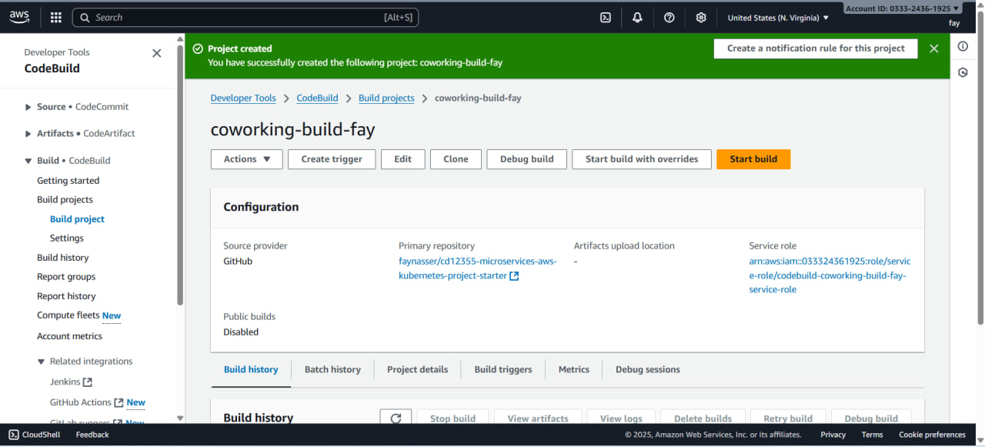

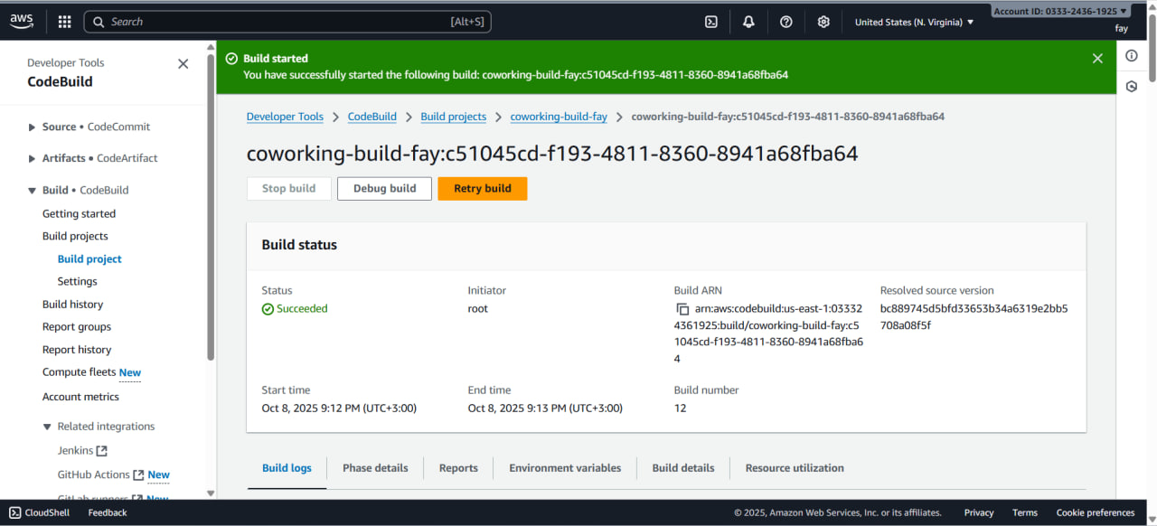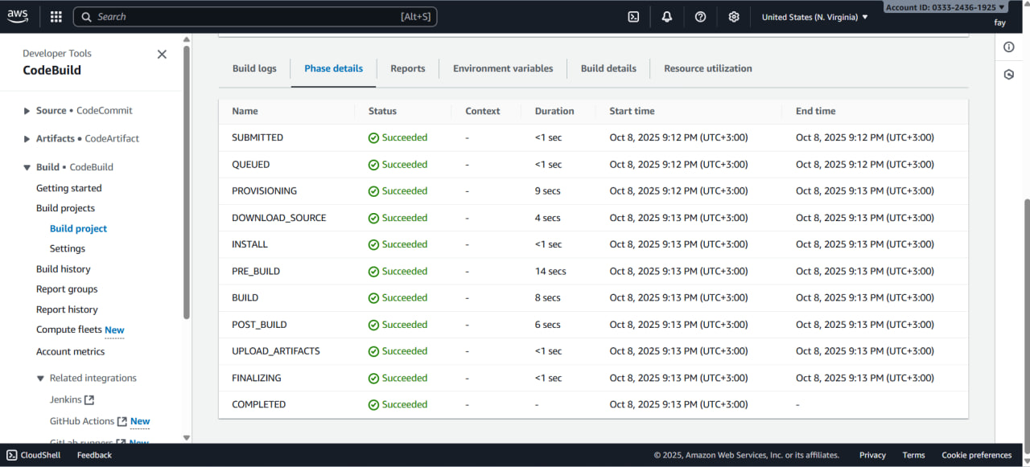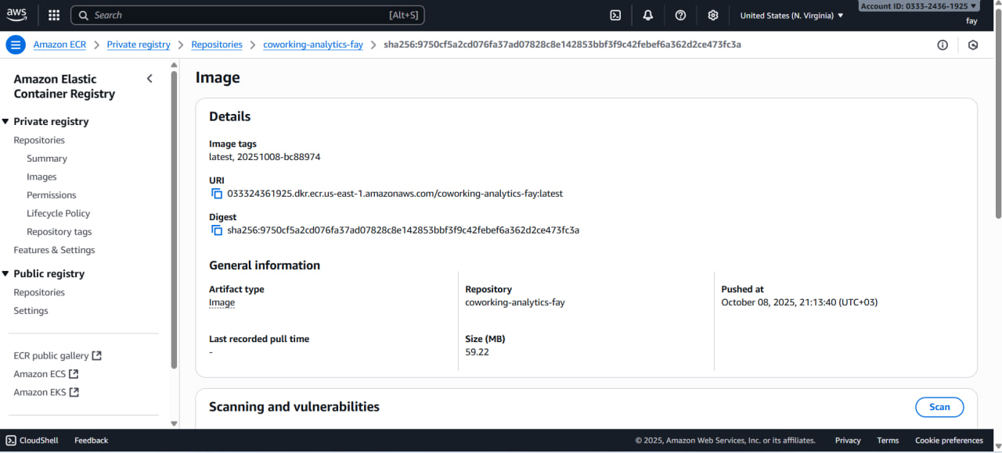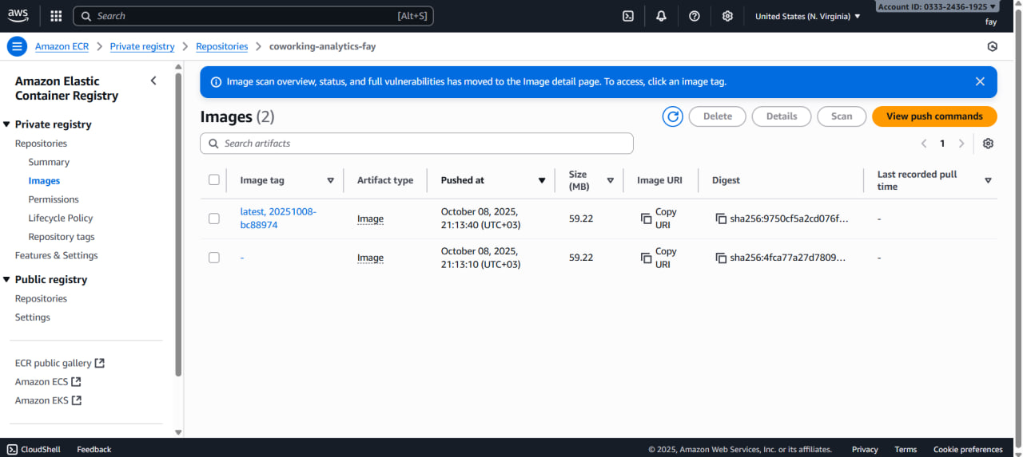

**AWS ECR repository for the application's repository**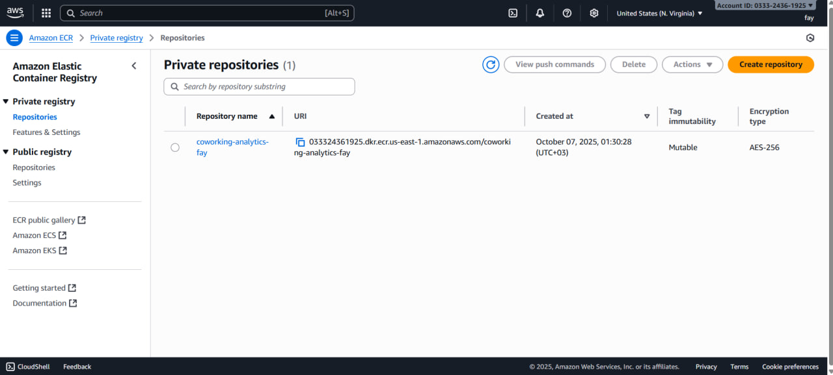

**EKS Cluster Creation**

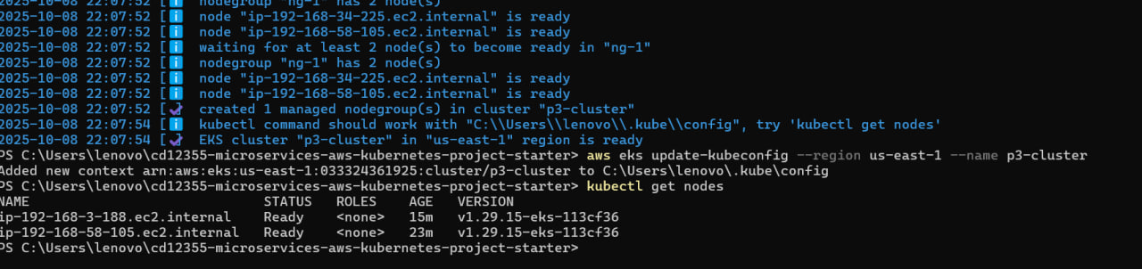

**Helm Installation of EBS CSI Driver**



**StorageClass Setup**

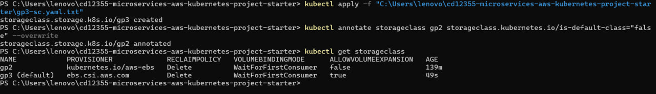

**App Deployment & Postgres**

**Pods Running**

**Services**



**Deployment Describe**

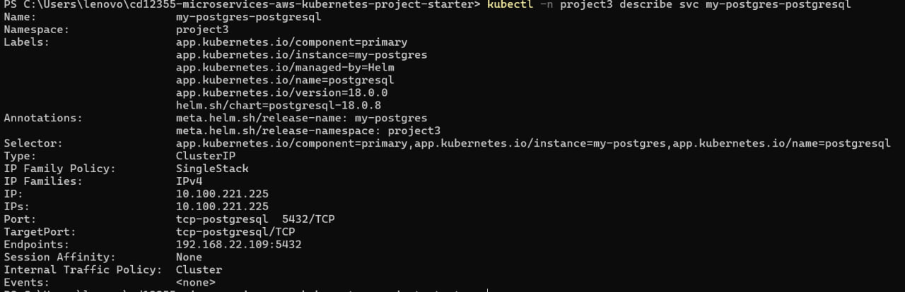

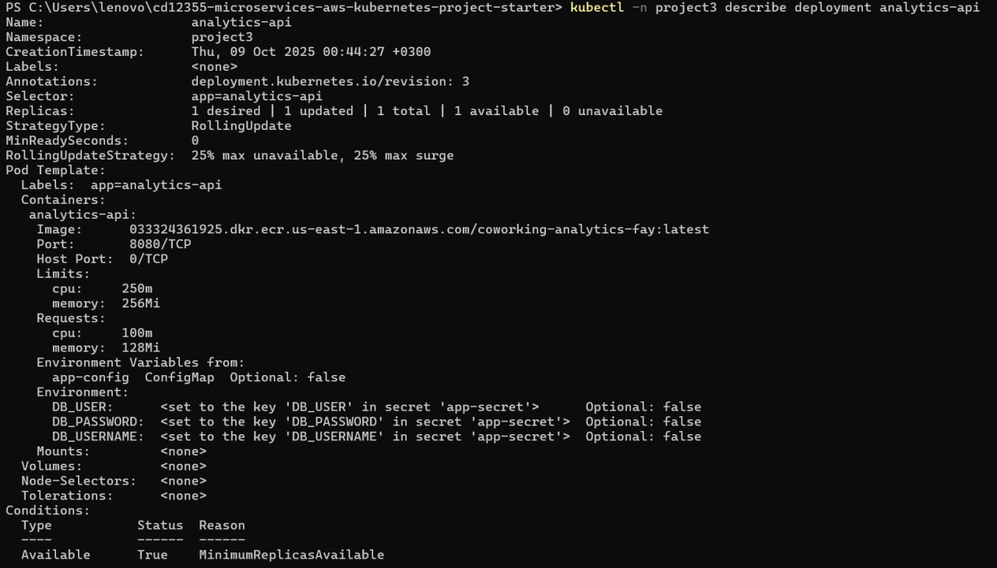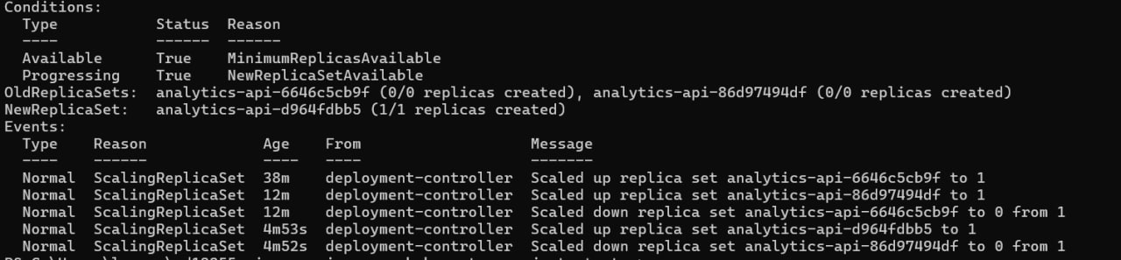

**Log Group in CloudWatch**

